Login as customer
AccountPro - Accounting Software
Customer login: cust1@gmail.com
Password: Test123@
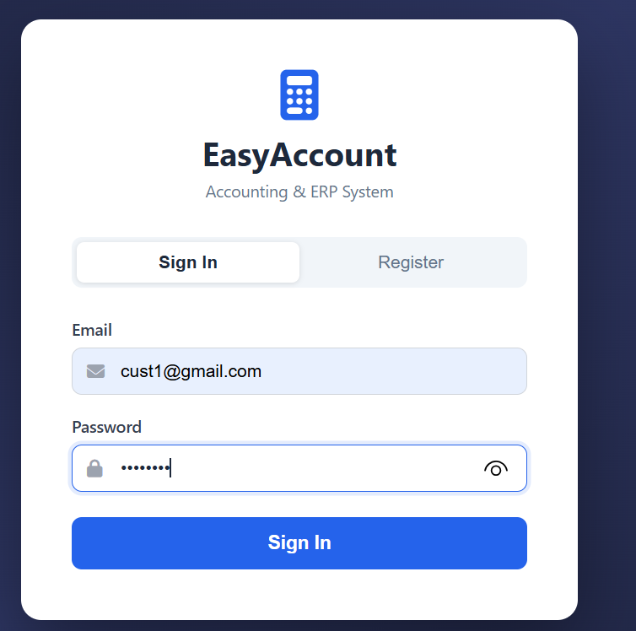
Customer Order Screen
When customer login he can see order screen. Where he can select required products using product description.
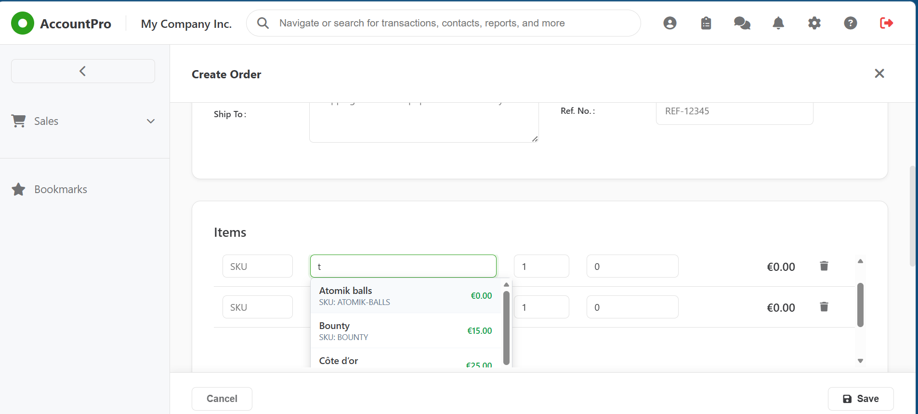
Admin user: qasimshah33@gmail.com
Password: Test123@
Admin user can view sale order. Admin can confirm the order using confirm button
Menu Sales Sales Order
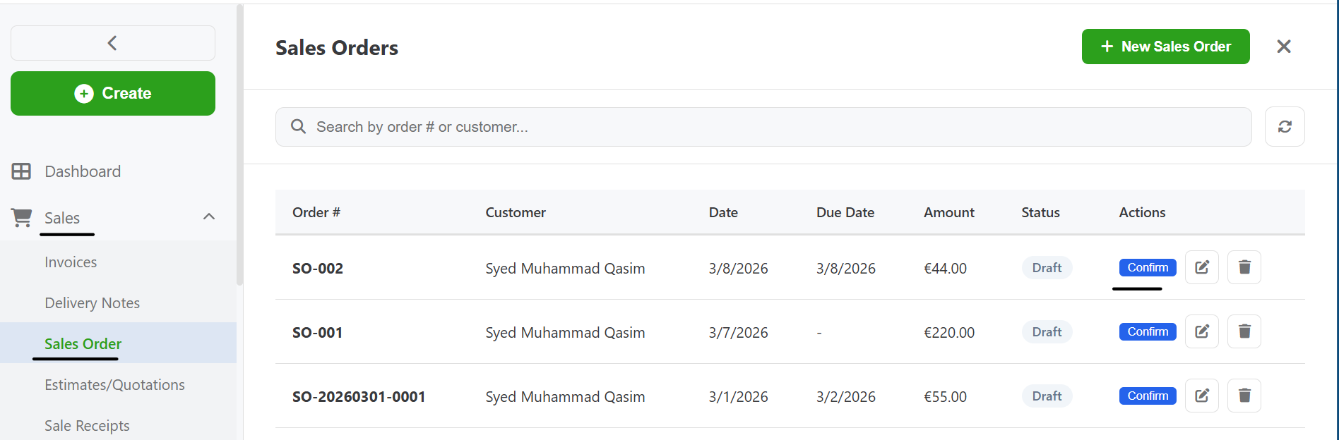
When admin press confirm button, order status will be confirmed.
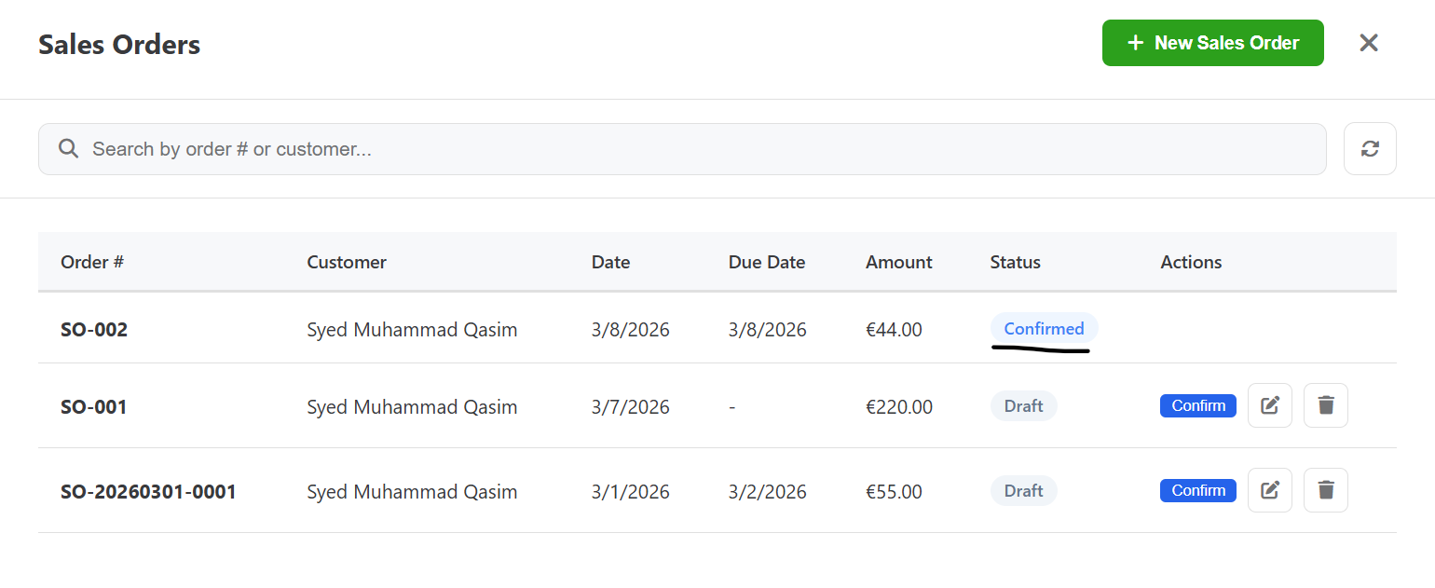

Admin can create delivery note by pressing Create DN button from sales order screen
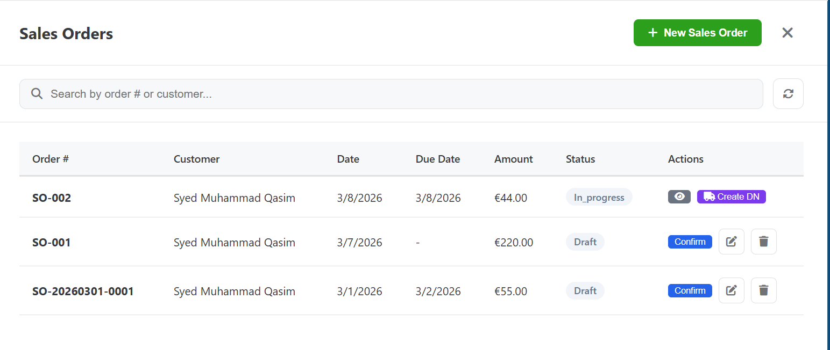
Sales Delivery Notes
When user press ship button. Inventory will be reduced
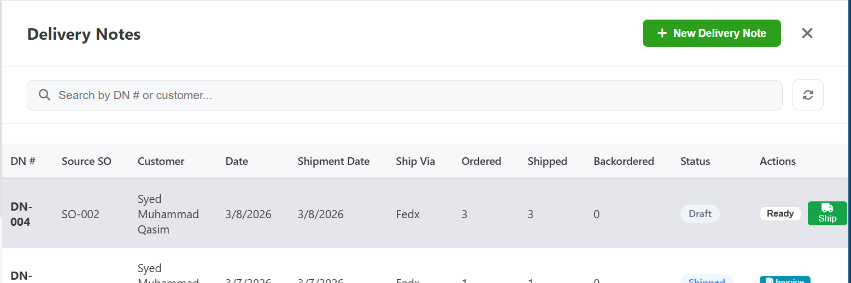

User can view order transaction from below screen
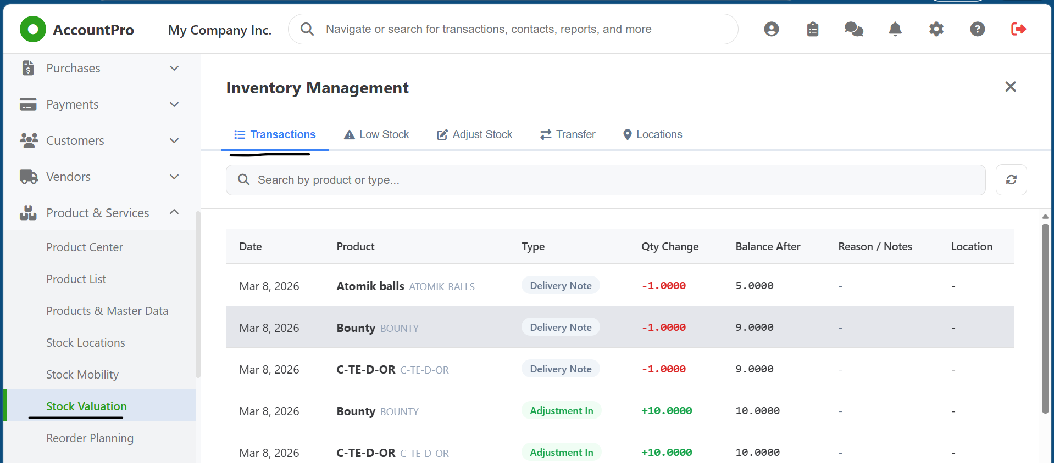
User can edit price of product from product center

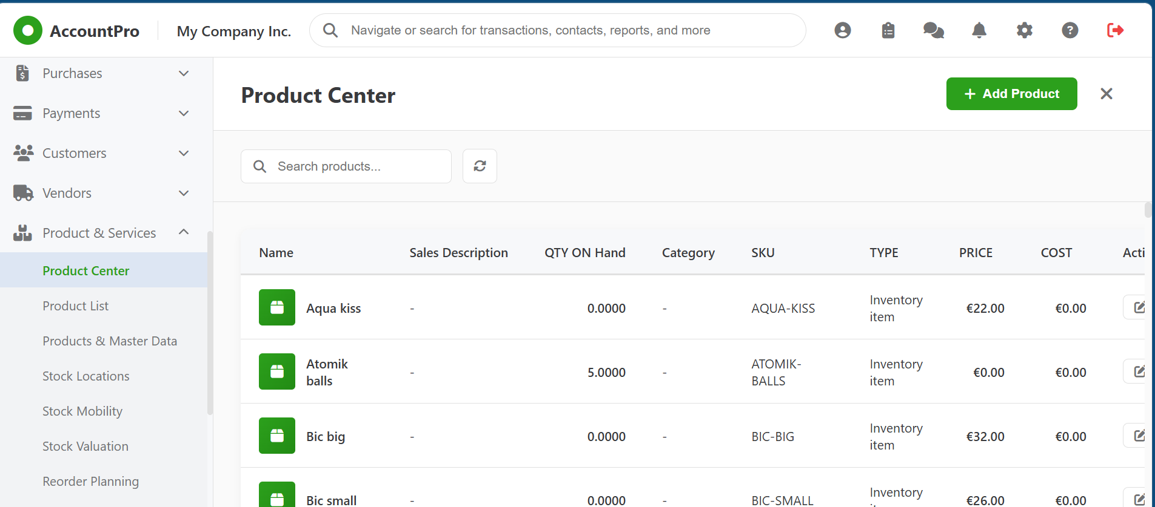

Admin user can create users from below menu
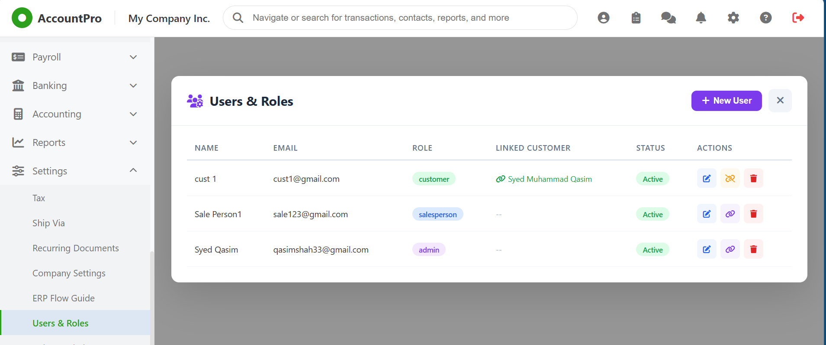

Sale person user
Login: sale123@gmail.com
Password: Test123@

